

**Department of Computer Science**

 **Learning Procedure**

1. Stage **J** (**Journey inside-out the concept**)
2. Stage **a1** (**Apply the learned**)
3. Stage **v** (**Verify the accuracy**)
4. Stage **a2** (**Assess your work**)

**COMSATS Institute of Information Technology (CIIT)**  
**Islamabad**

**Course: CSC101-Introduction To ICT**

**Statement Purpose:**

**LAB # 01**

This lab will provide a hands-on experience of **Microsoft Word**. Some basic features and functions of MS Word, which are mostly used while creating text documents, shall be taught and practiced.

**Activity Outcomes:**

The lab will teach students to **prepare different text documents** by:

* Using different **font styles, listing, and line and paragraph styles**
* Creating and formatting **tables**
* Inserting **cover pages, pictures, headers/footers, word art**, etc.
* Drawing various **diagrams**, using built-in shapes
* Using different **page layout** options

1. **StageJ(Journey)**

**Introduction**

In computing, the term text processing refers to the discipline of mechanizing the creation or manipulation of electronic text. Text usually refers to all the alphanumeric characters specified on the keyboard of the person performing the mechanization. Text processing involves computer commands which invoke content, content changes, and cursor movement, for example to search and replace, format, generate a processed report of the content, or filter a file or report of a text file.

Microsoft Word is word processing software that is used to manipulate a text document, such as a resume or a report. Text is typically entered by typing and the software provides tools for copying, deleting and various types of formatting. Some of the functions of MS Word include creating, editing, saving and printing documents, copying, pasting, moving and deleting text within documents, formatting text such as font type and style, creating and editing tables, inserting elements from other software, such as illustrations or paragraphs and, correcting spelling and grammar.

1. **Stage a1 (apply)**

**Lab Activities:**

**Activity 1:**

Create a new word document, save it on your Desktop and close it.

**Solution:**

1. Start MS Word.
2. The screen will display an empty document (New Word file).
3. Type the following paragraph.

**Consider this sentence: “Computers are everywhere.” Does it sound like an overstatement or a cliché? No matter how you perceive the impact of computers, the statement is true. Computers are everywhere. In fact, you can find them in some pretty unlikely places, including your family car, your home appliances, and even your alarm clock!**

1. To save the file, click on Save button  on the top left corner of the screen. You can also use the shortcut keys (Ctrl + S) to save the file. The Save button can also be reached by going to File tab on the top left corner.
2. The Save As dialog box will appear. The cursor will be active in file name drop-down box . Type a name for this new file. Name it **MyDoc.**
3. Select Desktop as saving location from left pane of Save As dialog box. The location bar will now be set to Desktop.
4. Left click on the Save button  at the right bottom of the dialog box. Your file is now saved on Desktop.
5. Close the file by going to File tab and clicking on Close option.

**Activity 2:**

Open the file you created in Activity 1. Change the font face and size.

**Solution:**

1. Click on File tab. Select Open . The Open dialog box will appear.
2. Set the location of the file you want to open. In this case, your file is located on Desktop. Set Desktop as location from the left pane of dialog box. The location bar will now be set to Desktop.
3. Select the file MyDoc from the right pane of the dialog box. The file name will appear in File Name drop-down box.
4. Right click on Open. The file will now be displayed on the screen.
5. Change the original text to following format.

Consider this sentence: “Computers are everywhere.” Does it sound like an overstatement or a cliché? No matter how you perceive the impact of computers, the statement is true. Computers are everywhere. In fact, you can find them in some pretty unlikely places, including your family car, your home appliances, and even your alarm clock!

1. To make the above changes, first select C of ‘**Consider’** using your mouse. Change its font size to 18 or larger by selecting the size from Font Size option. You can either select the small arrow or type in the desired font size in the box.
2. Font size can be incremented or decremented by using Grow Font (Ctrl+>) and Shrink Font (Ctrl + <) options respectively. You can see shortcut keys for different options by moving cursor over that option.
3. Select “**Computers are everywhere**” using your mouse. Change the font face to Algerian by selecting it from the font face box. You can either use the small arrow or type in font name in the box. Font face will now be selected to Algerian.
4. Save the changes by pressing Ctrl+S or .

**Activity 3:**

Change the case of the text to lowercase, UPPERCASE and other capitalization options.

cONSIDER this sentence: “COMPUTERS ARE EVERYWHERE.” Does It Sound Like An Overstatement Or A Cliché? No matter how you perceive the impact of computers, the statement is true. Computers ARE everywhere. In fact, you can find them in some pretty unlikely places, including your family car, your home appliances, and even your alarm clock!

**Solution:**

1. Select ‘**Consider’**. From the toolbar/ribbon, click on small arrow besides change case option. A list of options will appear. Select toggle case. This will change all lower case letters to upper case and vice versa.
2. Select ‘**Does it sound like an overstatement or a cliché?**’ Click small arrow again to display different case options. Select. This will change the first letters of all words of this sentence to uppercase.
3. Select ‘**are’** in the sentence ‘**Computers are everywhere**.’ Again, click the small arrow and choose option. This will capitalize all letters of the selected text.
4. Check remaining options and see the difference.
5. Save the document using  or Ctrl+S.

**Activity 4:**

Use Bold, italics, underline, strike through, superscript and subscript options, and other Font options and make following changes.

cONSIDER this sentence: “COMPUTERS ARE EVERYWHERE.” *Does It Sound Like An Overstatement Or A Cliché?* No matter how you perceive the impact of computers, the statement is true. Computers ARE everywhere. In fact, you can find them in some pretty unlikely places, including your ~~family car~~, your **home appliances**, and even your alarm clock!

**Solution:**

1. Using your mouse, select “**Computers are everywhere**.” Choose underline option from the font toolbar. You can change different line styles by clicking on the small arrow beside this option. You can alternatively press Ctrl+U for the same.
2. Select ‘**Does It Sound Like An Overstatement Or A Cliché**?’ Choose italics option from the font toolbar. You can perform the same function by pressing Ctrl+I.
3. Select ‘**consider’**. Choose subscript option or press Ctrl+=.
4. Select ‘**RE’** from ‘**ARE’**. Choose superscript option or press Ctrl+Shift++ keys.
5. Select ‘**family car’**. Choose strikethrough  from font toolbar.
6. Select ‘**home appliances’**. Click on the bold option from the toolbar or press Ctrl+B for bolding it out.
7. Select ‘**the statement is true**.’ Choose highlight option. You can pick a different highlight color by using the down arrow with the option.
8. Select ‘**alarm clock!’** using the mouse and right click on Font Color option. You can find a variety of colors by using the down arrow.
9. If you want to clear all the text formatting, simply click on.
10. Save the document using  or Ctrl+S.

**Activity 5:**

Using different paragraph options, write the given paragraph.

**Consider this sentence: “computers are everywhere.” Does it sound like**

1. **an overstatement or**
2. **a cliché?**

**No matter how you perceive the impact of computers, the statement is true. Computers are everywhere. In fact, you can find them in some pretty unlikely places, including**

* **your family car,**
* **your home appliances, and**
* **even your alarm clock!**

**Solution:**

1. Create a new MS Word document. Write the given paragraph as you did in activity 1. Make it bold (Ctrl+B or select).

**Consider this sentence: “Computers are everywhere.” Does it sound like an overstatement or a cliché? No matter how you perceive the impact of computers, the statement is true. Computers are everywhere. In fact, you can find them in some pretty unlikely places, including your family car, your home appliances, and even your alarm clock!**

1. Place your cursor after ‘**like’** in line # 2. Press Enter from keyboard. Now position the cursor after ‘**or’** and press Enter. Place the cursor after **‘?**’ and press Enter. Select the following lines.

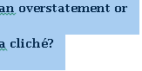

1. Select down arrow of Numbering option from Paragraph toolbar. You will see different numbering styles/formats. Choose the following format.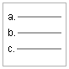
2. Again select the same text. From the paragraph toolbar, click on the down arrow of line and paragraph spacing. You will see different spacing options. Select 1.5. Try using other options too and note the difference.
3. Repeat step 2 for ‘**your family car, your home appliances, and even your alarm clock!**’ to have them in new lines (as shown below). Select the text.

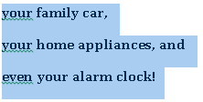

1. Choose Bullets option  from the toolbar. You can change the style of bullets by selecting the down arrow. Re-select the text and change the line and paragraph spacing to 2.5 (as was done in step 4).

**Activity 6:**

Type-in the following text in either a new word document or an existing one, using different paragraph options.

1. Main item # 1.
   1. Sub-item 1.1.
      1. Sub-sub-item 1.1.1.
      2. Sub-sub-item 1.1.2.
   2. Sub-item 1.2.
2. Main item # 2.
3. Main item # 3.

**Solution:**

1. Write ‘**1. Main item # 1’**. Don’t forget to add single space after ‘**1**.’ by using the spacebar on the keyboard. Press Enter from the keyboard. You will see that numbering automatically starts. You can start numbering in any format, e.g. 1.1./a./ A) etc.
2. Add the remaining Main items, i.e. Main item # 2 and Main item # 3 using the same procedure as of Step 1.
3. Once you are done with all the Main items, start with sub-items. Place the cursor after ‘**Main item # 1’** and press Enter. A new item # 2 will appear. Use backspace key of the keyboard and delete the number 2. Now type ‘**1.1. Sub-item 1.1**.’ Don’t forget to add a space after ‘1.1.’
4. Press Enter. A new numbered item 1.2. will appear on the document. Write ‘**Sub-item 1.2.’** after it.
5. Place the cursor after ‘**1.1. Sub-item 1.1**.’ Press Enter. Delete **1.2**. by using the backspace key from the keyboard. Write ‘**1.1.1**.’ and press spacebar once. This will add another level of numbering. Write ‘**Sub-sub-item 1.1.1.**’ in front of 1.1.1.
6. Press enter and repeat step 4 for 1.1.2. item.

**Activity 7:**

Insert different pages in a Word document such as Cover page or a blank page. Cover page is the first page of any document that displays the title, date, author name, organization name, etc. Blank page is a new empty page that is added at the cursor position.

**Solution:**

1. Open MyDoc that was created in activity 1.
2. Select the Insert tab from the toolbar.
3. You will see different page options in the Page ribbon. Select Cover Page option . The down arrow will display different styles of cover pages. Select any format of your choice. A new cover page is now added to the start of your document.
4. Edit different text boxes on the cover page, selecting them and filling in the appropriate information.
5. The cursor is at cover page. Now add a blank page by selecting  from the ribbon. A new page will be inserted after cover page.
6. Save the document.

**Activity 8:**

Insert following tables in the document. Table 1 should be inserted by selecting the matrix from the option and Table 2 should be created by entering the number of rows and columns in the Insert Table dialog box.

|  |  |  |  |
| --- | --- | --- | --- |
| Table 1 |  |  |  |
|  |  |  |  |
|  |  |  |  |

Table 2

|  |  |  |  |  |
| --- | --- | --- | --- | --- |
| Introduction | To | Information | And | Communication |
| Technologies |  |  |  |  |

**Solution:**

1. Open an existing document or create a new one.
2. From the Insert tab , select the Table option  by clicking on its down arrow. You will see matrix in the form of rows and columns. Roll your mouse over this matrix and different numbers of rows and columns will be highlighted. Select a matrix of size 3x4.
3. A table with fixed cell size will be inserted in the document where the cursor is located.
4. Type in **Table 1** in first cell of the table.
5. Write **Table2** just below the table and press Enter.
6. Re-select Table option  by clicking its down arrow. Select the option Insert table at the bottom. Insert Table dialog box will appear as given below.

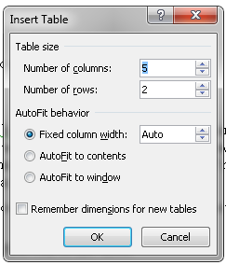

1. Write 5 in Number of columns box and 2 in Number of rows as shown above. You can set the cell size in AutoFit behavior. Select AutoFit to contents. This will resize cell size as you type-in text. Press OK.
2. A table will be inserted in the document at location where the cursor was placed. Write **Introduction to Information and Communication Technologies** in different cells (as shown in activity description). You can place cursor from one cell to next by either using mouse or pressing the Tab key on your keyboard.
3. If your roll your cursor over the table, you will see different options to format table by right clicking on.

**Activity 9:**

Insert a picture to the document. Apply different options to it.

**Solution:**

1. Open an existing Word document or create a new.
2. Place the cursor on a location on the page where the picture should be inserted. In the Insert tab , select Picture from the Illustrations ribbon. An Insert Picture dialog box will open.
3. Go to the location where the picture is saved in the computer. Select the picture from the right window and select Insert button . You can also click on the down arrow on the button to see different insert options.
4. The selected picture will be inserted to the document where the cursor was located.
5. Click on the Picture Tools tab, available on top of the window/screen. Format tab will now be visible, displaying several picture related formatting options.
6. Try formatting the picture by applying different styles from the style ribbon .
7. Add border to the picture by selecting Picture Border’s down-arrow .
8. Different picture effects can be applied using.
9. Insert another picture following same steps; however, this time, try inserting the picture in the middle of a paragraph. Try different Position and Wrap Text options to the picture and see the difference.
10. Select one of the pictures in the document. Go to Picture Tools and then Format tab. Use the crop feature to crop the picture. Also rotate your picture 90 degrees anticlockwise using either Rotate option in the toolbar or rotating the green circle over the picture using the mouse.
11. Save the document.

**Activity 10:**

Insert drawing canvas and draw the given diagram using different shapes. Group the different shapes used to make one.

Hello

**Solution:**

1. Open an existing word document or make a new file.
2. Place the cursor on a location on the page where you want to insert canvas.
3. From the Insert tab, select Shapes option by clicking its down-arrow. A list of different shapes will appear.
4. Select Rectangle under Basic Shapes group. Now draw this rectangle, of any size, on the page using mouse.
5. Now select an arrow from Lines group and draw a line from the lower mid of the rectangle downwards.
6. Now select a circle from Basic Shapes group and draw it just below the arrow.
7. If you want to format any shape, click on the shape. Drawing Tools option will appear on over the toolbar. Select this option and different format options will be available to format the selected shape. Alternatively, you can select a shape and click right on it. Different format options will appear.
8. Right click on the drawn rectangle and select Add Text feature. Now write **Hello** inside Rectangle. You can format text (change color, style, size etc.), as done in previous activities.
9. To group all the shapes, click on rectangle first. It is now selected. While keep pressing Ctrl key on your keyboard, move cursor on arrow. An arrow with a plus sign will appear. Select the arrow too. Remember to keep pressing Ctrl key. Now move cursor near the circle. Select it when you see an arrow with a plus. Now all the shapes you have drawn on the canvas have been selected. Relieve the Ctrl key.
10. Move mouse over the diagram and see when you get cross arrow 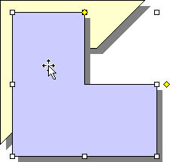. Right click and choose Grouping and then Group.All the shapes have now been grouped together to make a diagram. You can now drag/rotate the diagram as a whole.
11. Save the document.

**Activity 11:**

Insert a header, footer, page numbers and a math’s equation ($A=πr^{2}$) in a Word file.

**Solution:**

1. Open an already existing file.
2. Go to Insert tab. Click on the down-arrow of Header option in Header & Footer section. A list of header options will appear. Select a header of your choice and you will header on every page of your document.
3. The header can be edited and formatted by using different options in Header & Footer Tools. When you are finished, choose close header and footer.
4. You can insert footer to your document by following the same steps. Click on the footer option  in the Insert tab. A list of footer styles will appear. Select one.
5. Design the footer by using different features of Header & Footer Tools. Once designed, close the header and footer.
6. For inserting page numbers, go to Insert tab and select down arrow on Page Number option. Different options will appear. Select Top of Page. Then, among different styles, choose one style of your choice.
7. Page numbers can be formatted by selecting Format Page Numbers option  . Header & Footer Tools also let writers to format page numbers.
8. For inserting the given math’s equation, place the cursor at the appropriate place on page. In the insert tab, there is a Symbols section. Select the down arrow of Equation option. There are many built-in equations.
9. Select Area of Circle and that equation will be inserted into the document. You can edit the equation as well by overwriting with your own variables.
10. When the equation is selected, Equation Tools  will appear on top of the window. This will let you format the selected equation by applying different options, such as using different symbols and structures (fraction, script, radical, integral, large operator, bracket, function, limit and log, matrix, etc.).
11. Save the document and exit.

**Activity 12:**

Design the layout of document pages. Apply different themes, setup page, and page background.

**Solution:**

1. Open an existing Word document or make a new Word file.
2. Go to Page Layout tab. On the left-most side of the toolbar, there is a Themes option. Click on its down arrow and choose a theme for your page. This option will change the overall design of the entire document, including colors, fonts and effects.
3. You can also customize color, font, or effects under a theme by selecting Colors, Font, and Effects options respectively.
4. In the page layout tab, you will find Page Setup section that will enable you to setup page margins, change page orientation (portrait or landscape)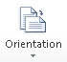, page size, and page columns that will split the text into two or more columns. Try applying these options.
5. In the same ribbon, you can number every line of your document by using Line Numbers option.
6. In the same Page Layout tab, there are various options for designing the background of pages. Watermark option will insert ghosted text behind the content of the page. You can change the color of the page by utilizing the Page Color option. Borders can be inserted too by using the Page Border option.
7. Apply these features and save the document.
8. **Stage v (verify)**

**Home Activities:**

**Activity 1:**

You are required to create your personal letterhead. It must include:

* Your name – use Word Art
* Your address
* Your phone number
* Your email
* Your website URL
* Graphics that pertain to you

The placement/location of the items is up to you. Letterheads must extend no more than 2 inches from the top of the page. Display the ruler bar and adjust the vertical ruler to the top of the page. Save as “letterhead your name”.

**Activity 2:**

Open the letterhead you created in activity 1. Resave (Save As) and name it “WPexer2 your name.” Type the letter below using the following instructions:

* Center the words “(your name) Corporation”
* Insert the date (do not type it in).
* Mr. Richardson’s name and address are single spaced.
* Underline the words “confirmation” and “9 p.m.”
* Bold the words “no cost”, “November 25th”, “Norseman Inn” and “Cappy’s Capers”
* Put approx. 4 blank lines after “Warmest regards” to allow space for a signature
* Your first and last name are typed at the bottom
* Save

*(Your name)* Corporation

*(Current date)*

Ms. Patsy Richardson

123 Main St. *Single spaced*

Winnipeg, Manitoba

R2B 5F2

Dear Ms. Richardson

This letter is a confirmation of your request for a ticket to the Annual Fireman’s Ball. Our corporation is happy to provide the ticket to you at no cost.

As you will note from the tickets, the Ball is being held November 25th at the Norseman Inn and will begin promptly at 9 p.m. The famous band, Cappy’s Capers, will provide an entertaining evening of dancing and comedy.

Thank you for allowing our company to be of service to you.

Warmest regards,

(Your name)

**Activity 3:**

Tabs can be left, or right aligned, centered or decimal tabs. All tabs can have dot leaders.

1. Type the exercise below down through (to and including) the first paragraph.
2. **After** you have typed the first paragraph, delete all tabs.

(On the **Home** tab or the **Page Layout** tab, click the **Paragraph** dialog box launcher. In the **Paragraph** dialog box, click **Tabs,** click **Clear all**)

1. **Before** you start typing the line “Store # 1…, set the following tabs

Left tab 0.5” Centered tab 2”

Right tab 3.5” dot leader decimal tab 5.5”

1. Type the columns of information on the stores.
2. Save your document as “WPtabsA your name”

**To: Tom Jennings**

**From: (your name)**

**Re: Monthly report of widgets sold to date**

**Date: (use current date)**

**Tom, the following monthly sales figures seem to indicate that the new item we are offering for sale is taking the market by storm. I would suggest that we continue to advertise as originally planned.**

**Store#1 ClearWater #A459………………..$356**

**Store#2 Camrose B375…………………..205**

**Activity 4:**

Create a blank invoice table as shown below.

* Use your own name
* Use your own graphics and type of business
* Shade the cells as shown
* Save as “Invoice Table *your name*”

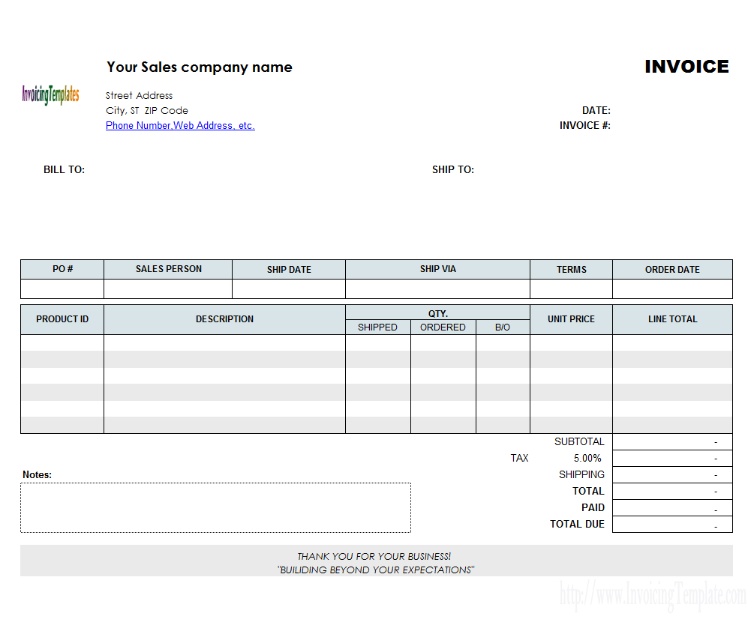

**Activity 5:**

Draw the figure given below. Use different shapes and group them.

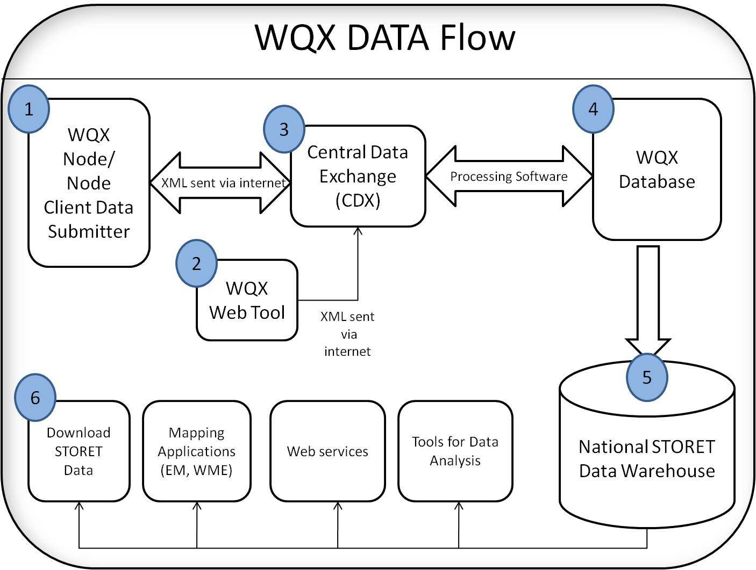

1. **Stage a2 (assess)**

**Assignment:**

Deadline: at the start of next lab

A flyer is a pamphlet, which is a form of paper advertisement intended for wide distribution in a public place, handed out to individuals or sent through the mail.

Consider you work at a company. Your boss has asked you to prepare a flyer that advertises company’s major products and/or services.

Two sample flyers are given below.

